PBGateway

PSI control system is split over multiple networks, and requires at least a read access of the EPICS process variables (PV) across the networks and in some case write access. During the development of the FEL project the usage and load on the EPICS gateway grow to the point to prevent further usage of the existing gateway developed by Kenneth Evans, Ralph Lange, and Dirk Zimoch. It simply does not match the needs anymore.

Therefore a new gateway design has been developed and programmed at PSI by Matteo Provenzano and Alain Bertrand using C# and .NET 4.0.

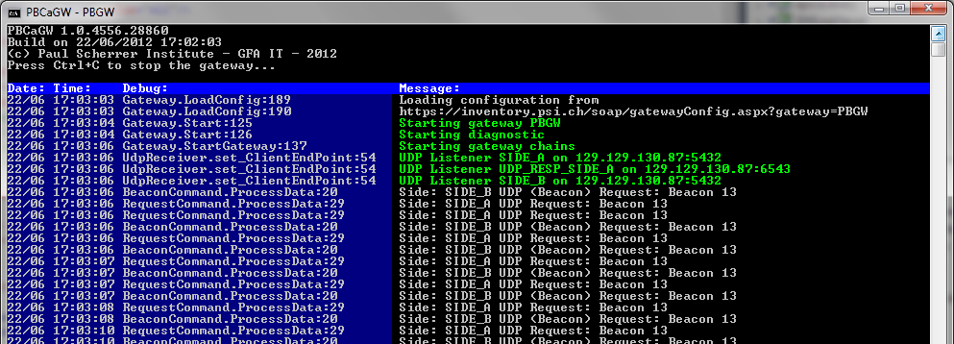
Epics gateway concept:
EPICS uses both UDP and TCP to communicate in broadcast for UDP and unicast for UDP and TCP. Broadcasts are normally not propagated across networks. Firewalls or other network designs prevent the correct EPICS communication, therefore a specially crafted software; like a proxy or router is needed.

This proxy / router software is called an EPICS gateway and besides allowing the protocol to pass through different networks it allows to implement security rules, and decrease the load on the IOC by offering either cached value as well as reducing the searches on the control network.

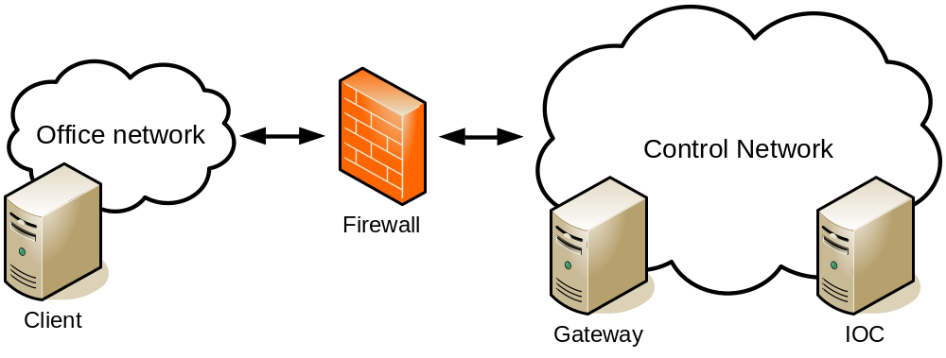

The gateway can either be behind the firewall, and work with 2 different ports, or can be across the 2 networks and work with 2 different IP addresses.

The gateway will be seen in both cases as the IOC for the clients and as a client for the IOCs (cainfo will return the gateway as the IOC of the forwarded channels). One may therefore think it is both an IOC and a client, and it is indeed the case for the Kenneth Evans et al. gateway design (described afterward), however in our design it is not exactly the case.

Security rules define which channels can be accessed in which way and by whom. The channels are described with a simplified regular expression like "ARIDI-*" which means all channels starting with "ARDI-".

The IOC load reductions comes from the fact the gateway will cache search results (in case the channel has been found), share TCP connections, virtual circuits or even cache values (depending on the implementation).
Kenneth Evans et al. Gateway design:

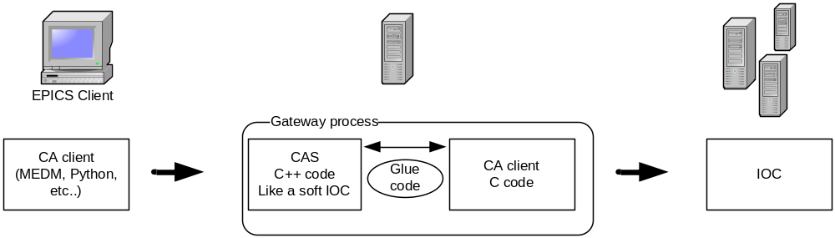

The gateway is composed of an IOC part (using the CAS library) and a client part (using the standard CA library) with some "glue code" to merge the two parts. Advantage of this design, is that as long as the API doesn't change, a simple recompile or dynamic link should be sufficient to keep the gateway up to date to protocol changes. Also, it can fully offload the IOC as it can cache searches and values.

Alain Bertrand & Matteo Provenzano design

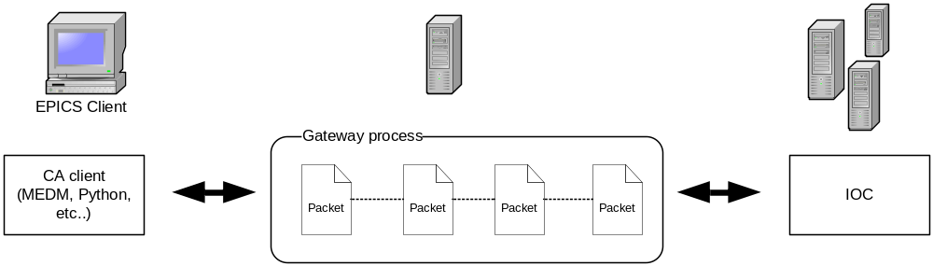

The gateway act as a router or firewall, and only partially decodes the messages / packets. The gateway is not a true client / server and is mostly passively forwarding requests from one side to the other (with some rules for the security and some optimizations like sharing connections and virtual circuits).

Advantages of this design:
- Lower latency (doesn't need to wait for a complete multi-packet message before sending the first packets).
- Lower CPU usage (as it doesn't need to completely decode the message and recode it, instead it mainly copies what it receives and builds new messages bases on it).
- Lower memory usage (as it doesn't create a memory variable for each channel request).
- Handles easily large array or unknown data type as it doesn't need to decode the message.
- Fully multi-threaded (each message runs on his own temporary thread which is handled by .NET thread pool).
PSI Gateway requirements :
- Handle small and large requests efficiently.
- Security must be implemented on channel, IP, host and user level.
- A single process to handle both the forward and backward gateway (Side A, Side B)
- Multi-threaded to scale with the requests and optimally use the available hardware.
- Low memory and CPU footprint.
- Stable.
- Easy to debug (with logs and tools)
- Integration with the current tools (like the PSI Inventory Tool).
- Low latency (specially for large arrays).
- Works with 1 or 2 IPs.
- Works as uni or bi-directional.
- Code should be modular, yet relatively easily editable (therefore commented).

Technology & Design choice:
- C# and .NET 4.0 has been selected due to the knowledge of the group (used previously for various other projects), the high quality parallelism library, good socket implementation and quick development time.
- Configuration is stored in XML format (via XML serialization / de-serialization inside the code).
- IP Packets (TCP & UDP) are kept as packet inside the code, and only partially decoded when needed.
- Threads are mainly handled by .NET asynchronous socket handling and therefore handled by .NET thread pool.
- Temporary memory (which needs to be accessed in different code areas) is cleaned using self cleaning in house developed collections.
- "Worker Chains" are developed to describe the process applied on a given IP packet and are be split in "Workers" classes for the different process operations.
- "Handlers" are developed to describe the different message types composing the EPICS protocol.
- Logging is done using the .NET Trace library and 3 different TraceListeners are implemented (a console, an XML and a pseudo console listener).

Typical EPICS communication:
The following sequence diagram can be used to clarify a typical EPICS operation (read notify: caget):

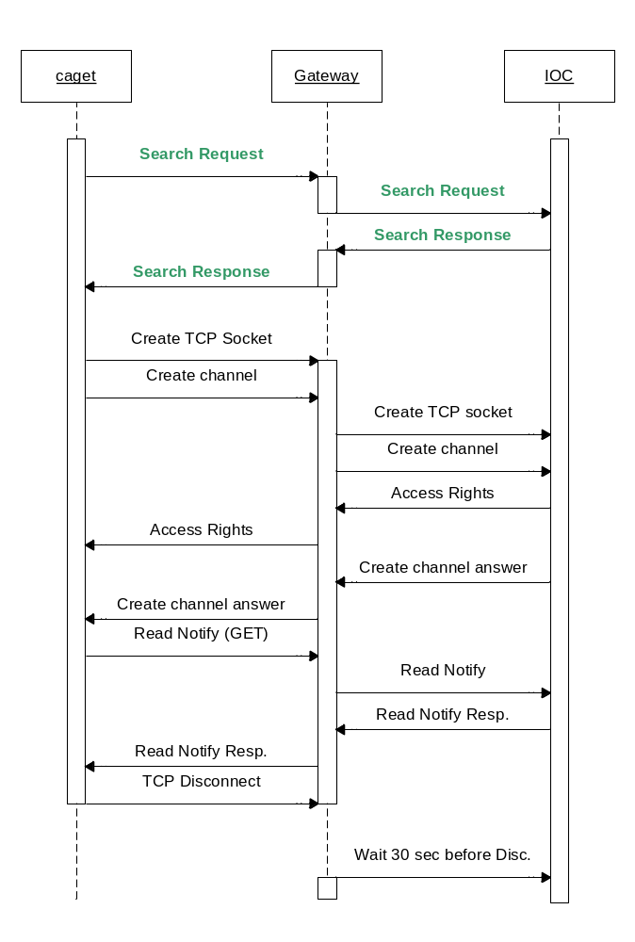
The vertical columns represents the 3 processes (caget, the gateway and an IOC). The green labels show UDP messages, where the black labels are TCP messages.

The boxes on the vertical line are used to show when the process has an active process or needs to keep some kind of state.

The gateway handles the UDP message as stateless process, where each TCP connection creates a worker chain.
Code structure:
An overview of the software is important to understand the different kind of classes the software is composed of. Details of the different kind of class are then further explained later in this document.

WorkerChain:
Worker chains describe a connection and the processing of the packet received from the UDP or TCP receiver which are the first node of any chain.
A chain is composed of multiple Workers linked one after the other like a linked chain.

Worker:
Workers are the actors of a worker chain, and are responsible of a single task over the data block they receive.

CommandHandler:
A command handler is responsible to react to an EPICS request or response. For each EPICS message, a different command handler will be called.

Beside those main categories, the software uses a storage class (InfoService), a logger (Log), configuration and security, as well as some independent classes.

The first called class should be the Gateway class which is basically the gateway software. (Read: startup of the gateway)
Worker Chain:
A worker chain is composed of a list of "Workers" which are responsible for different activities on the same "Packet". The first worker of any chain is either an UDP receiver or a TCP receiver, which actually produces the packet and then flow along the chain.

There are four main kind of worker chains:

UDP Receiver chain (created once at startup):

UDP Response chain (created once at startup):

TCP Receiver client chain (created while a client connects to the gateway):

TCP IOC chain (created when we the gateway needs to connect to an IOC):

Note that workers with the same labels in the above diagrams are actually the same classes in the code.

Passing a message from one worker to the following worker in the chain is handled via a C# event. Thanks to this design one packet can be split and multiple sub-packets can be received by the next worker on the chain.

The process inside a single chain is sequential allowing to follow the communication within a single chain while debugging (via the stack trace).

Between the different Worker the class DataPacket is used as data block containing the content of the IP data block or the EPICS message.

The parallelism of the chains is handled by the asynchronous TCP receive API, and therefore uses the .NET thread pool for it.
Chain Creation & Life cycle:
The UDP chains are created during the startup of the gateway while the TCP chains are either created when a new connection is received from a CA client or when the gateway needs to communicate with a new IOC over TCP.

The creation of the chains is handled via static functions inside the WorkerChain class:

- WorkerChain.UdpChain
- WorkerChain.UdpResponseChain
- WorkerChain.TcpChain
- WorkerChain.TcpResponseChain
- WorkerChain.UdpBeaconReceiver

The WorkerChain class keeps a reference to the newly created chains inside the static knownChains list. This list is used for detect dead TCP chains and therefore cleanly dispose them.

UDP chains should not be disposed unless the gateway needs to restart or quit.

Workers:
All Worker classes must extend the abstract Worker class and implement the ProcessData function.
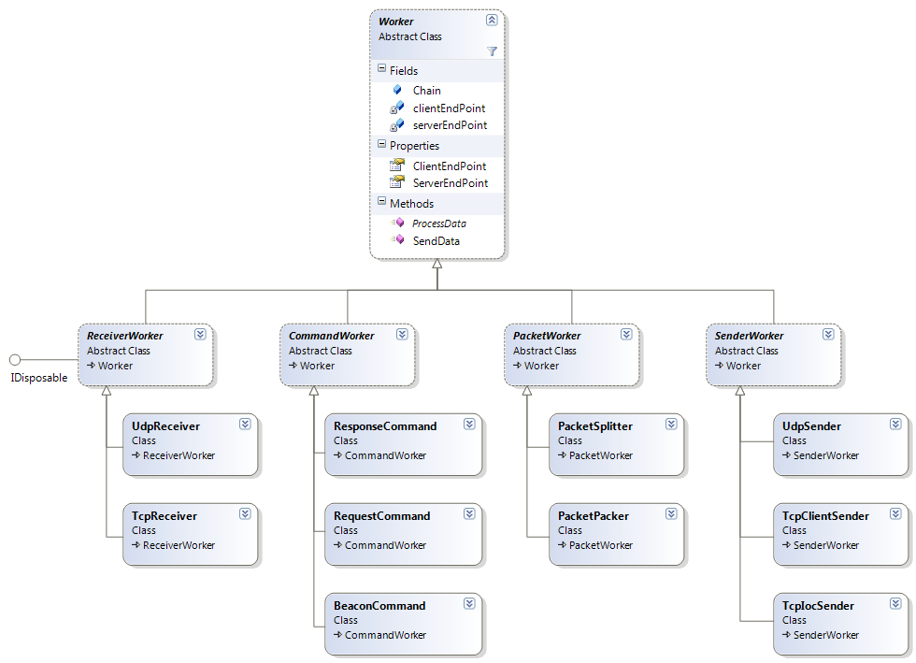
For clarity, the different workers have been split in sub-categories (Receiver, Command, Packet, Sender).

The communication between the different Workers is handled via the SendData function which will trigger an event and call the next Worker of the WorkerChain. The subscription of the event is handled by the WorkerChain factory.

This design has been chosen in order to code the different (logic) parts separately as well as being able to reuse the logic / code on the different WorkerChain.

The command workers use the CommandHandler class to be able to execute the needed operation.
Command Handlers:
For each (supported) EPICS command a corresponding CommandHandler class exists.
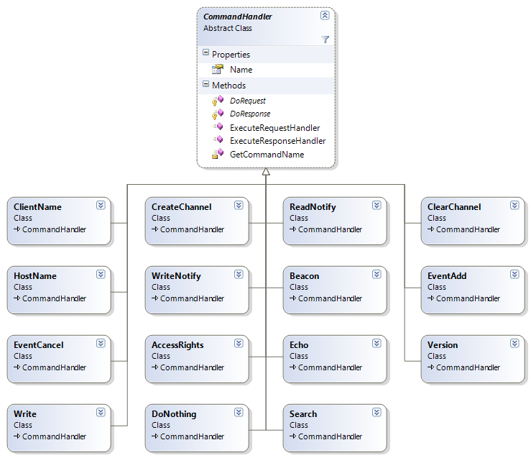

Each CommandHandler is composed of a DoRequest and DoResponse which handle respectively the Request Message and the Response Message. We have chosen to keep the Request and Response within the same class to be able to have a single file containing both and to develop both in parallel. It allows an easier overview of the whole message implementation at the cost that some messages will have only the request or the response.

CommandHandlers receive a DataPacket as input and can produce any number of Data (0 to many) via the SendData delegate which produce a list of DataPacket which ultimately need to be sent.
Startup of the gateway:
The gateway uses as main class the Gateway class, which needs to be instantiated. The following code is minimal form of a gateway:

static void Main(string[] args)
{
Gateway gateway = new Gateway();
gateway.LoadConfig();
gateway.Start()
Console.ReadLine();
}

The LoadConfig function will then extract from the app.config some configuration keys and tries to load the real configuration via web client.

To use the remote configuration, the app.config file must define:

<add key="gatewayName" value="PBGW" />
<add key="configURL" value="https://inventory/soap/gatewayConfig.aspx?gateway=" />

Where the URL will be the concatenation of the configURL and the gatewayName key.

The format of the result received from the URL is the same as the gateway.xml file. Once the data is received from the Web, the gateway will store (overwrite) the gateway.xml file with the content received, and will therefore be able to start, even if the web server doesn't answer.

In case the gateway fails to load the configuration via web or it is not configured to load from the Web, the gateway will fall back to a locally stored gateway.xml file. (The gateway.xml file is explained further on)

After the loading of the configuration, a single Start function needs to be called and all the UDP worker chains will be created, one or two TCP listener (GwTcpListener) will be setup as well as the diagnostic server will be started.

Configuration file gateway.xml:

<?xml version="1.0" encoding="utf-8"?>
<Config xmlns:xsi='http://www.w3.org/2001/XMLSchema-instance' xmlns:xsd='http://www.w3.org/2001/XMLSchema'>
<Type>UNIDIRECTIONAL</Type>
<Name>HIPA-TEST-GW</Name>
<LocalAddressSideA>172.22.200.117:5062</LocalAddressSideA>
<RemoteAddressSideA>129.129.130:255:5062</RemoteAddressSideA>
<LocalAddressSideB>172.22.200.117:5064</LocalAddressSideB>
<RemoteAddressSideB>172.22.255.255:5064</RemoteAddressSideB>
<UdpSenderPortA>5062</UdpSenderPortA>
<UdpSenderPortB>50123</UdpSenderPortB>
<Security>
<Groups>
<Group Name='PIM1'>
<Filters>
<Filter xsi:type='HostFilter'>
<Name>hipa-pim1</Name>
</Filter>
</Filters>
</Group>
</Groups>
<RulesSideA>
<Rule Channel='*' Access='READ'>
<Filter xsi:type='AllFilter'>
</Filter>
</Rule>
<Rule Channel='ASM11:*' Access='ALL'>
<Filter xsi:type='GroupFilter'>
<Name>PIM1</Name>
</Filter>
</Rule>
</RulesSideA>
<RulesSideB>
<Rule Channel='*' Access='NONE'>
<Filter xsi:type='AllFilter'>
</Filter>
</Rule>
<Rule Channel='IKA-KA2:*' Access='READ'>
<Filter xsi:type='AllFilter'>
</Filter>
</Rule>
</RulesSideB>
</Security>
</Config>

The file must be placed in the same directory as the gateway software and must be writable by the gateway process.

The file describes the main settings of the gateway (the different IP and ports used by the gateway) as well as the full security rules (Side A and Side B).

The gateway is always composed of 2 sides: Side A and Side B. In an unidirectional configuration the searches comes from Side A and goes to Side B, where in a bi-directional configuration searches can come from both sides.

The LocalAddress(SideA or SideB) defines the IP as well as the port on which the gateway will listen with the format: IP:PORT

RemoteAddress(SideA or SideB) defines a list of IP:PORT separated by semicolons (;) for the destination of the search and beacons packets. Usually those are broadcast addresses.

UdpSenderPort(A or B) defines from which port the UDP packets like Beacons and Search are produced. If left to 0 the gateway will pick a free port. However as the gateway may be restricted by a firewall, it's good practice to define which port to use.

The security rules filters must be one of the following:
Filter Type | Parameter | Description
AllFilter | No parameter | Will match any clients.
GroupFilter | Name | Will use a group (identified by the name) for the filter.
UserFilter | Name | Checks against the username passed by EPICS.
HostFilter | Name | Checks against the hostname passed by EPICS. This could be different from the real hostname of the client.
IPFilter | IP | Can contain a simplified RegExp and checks the IP of the client.

Rules are interpreted from top to bottom, and all rules will run, therefore the last rule which can be applied will set the access right. For example, if the first rule say "* no access" and the second say "A* read", it would mean that everything is blocked beside channels starting with A.

Simplified RegExp:
The gateway uses a simplified regular expression form:
The star (*) means any number of any character (.* for a standard RegExp).
The dot (.) means a dot and not a character of any kind.
The exclamation mark at starts reverse the expression.
Beside those differences, all the features of a regular expression can be used.
Logging:
The debug / logging of the Gateway operations is done via the standard .NET Trace solution. To improve the output of the Trace API, the gateway library contains 3 different listeners:

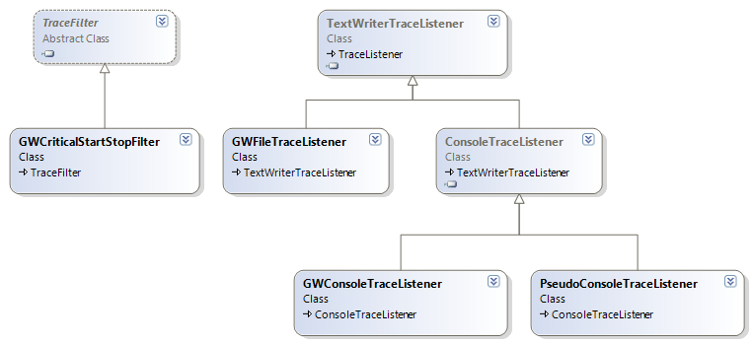

To be able to use them, the app.config file must define a trace source, as well as one of the listener. However as soon as a source is defined, the PseudoConsoleTraceListener will be added to it as it's only purpose is to replicate the output of the console via one of the debug channel.

<?xml version="1.0" encoding="utf-8" ?>
<configuration>
<system.diagnostics>
<switches>
<add name="GatewaySwitch" value="All"/>
</switches>
<trace autoflush="true" indentsize="4" />
<sources>
<source name="GatewaySource" switchName="GatewaySwitch" switchType="System.Diagnostics.SourceSwitch">
<listeners>
<add name="consoleLogger" type="PBCaGw.Services.GWConsoleTraceListener, PBCaGw">
<filter type="PBCaGw.Services.GWCriticalStartStopFilter, PBCaGw" />
</add>
<add name="fileLogger" type="PBCaGw.Services.GWFileTraceListener, PBCaGw" initializeData="c:\temp\gw.log" traceOutputOptions="None">
</add>
<remove name="Default" />
</listeners>
</source>
</sources>
</system.diagnostics>
<appSettings>
<add key="gatewayName" value="PBGW"/>
<add key="configURL" value="https://inventory.psi.ch/soap/gatewayConfig.aspx?gateway="/>
</appSettings>
</configuration>

Diagnostic server:
The gateway offers different channels for debug purpose which will be directly served by the gateway itself.

GW-NAME:CPU | CPU usage in % of the machine running the gateway.
GW-NAME:MEM-FREE | MB free of the machine running the gateway.
GW-NAME:NBCLIENTS | Number of clients connected.
GW-NAME:NBSERVERS | Number of servers currently connected to.
GW-NAME:PVTOTAL | Number of known PVs.
GW-NAME:MONITORS | Number of open monitors.
GW-NAME:SEARCH-SEC | Number of search message per seconds.
GW-NAME:LOGVIEW | Byte buffer reproducing the console view.
GW-NAME:RESTART | Set to 1 to reload the gateway configuration.
GW-NAME:VERSION | Version number of the gateway code.
GW-NAME:BUILD | Build date of the gateway.

Hard coded constants:
The class Gateway contains some constants which are currently hard coded, as they usually don't need to be modified.

CA_PROTO_VERSION | This is the version number of the protocol the gateway will send back.
IOC_KEEP_ALIVE_CONNECTION | Number of seconds the IOC connection is kept after the last client connected to this IOC dropped the connection.
ECHO_INTERVAL | Number of seconds without any traffic on a chain before the gateway tries to send an echo.
MAX_UDP_SEND_PACKET | Max number of byte an UDP packet can have.
BUFFER_SIZE | Size of the TCP and UDP receive buffer. If it's too small, some UDP packet can be lost. Too big will loose memory.
SENDER_DEAD_LOCK | Timeout before a sending process detect a deadlock.

Beacons:
Beacons are mainly used to inform clients that an IOC restarted, this allows the clients to restart the research and eventually connect or re-connect PV.

As the gateway is seen as an IOC and needs to inform potential clients if a real IOC restarted, the current algorithm waits till the 5th beacon is received from an IOC (by looking at the beacon ID), and then resets the gateway beacon as it was rebooting itself. This should trigger a fresh search on the client side.

